**Table of Contents**

**Promo Video** 1

**Tutorial Videos** 1

**Easy Performant Outline 2.0 Setup** 2

**URP Setup** 2

**DOTween Setup** 3

**Easy Performant Outline 2.0** 4

**Components** 4

**Parameters of Outlinable** 5

**Coding API** 8

Thank you for buying the **Easy Performant Outline**, we hope it will help you in your project.

If you liked our product, do not forget to rate it in an Asset store: <http://u3d.as/1EXT>

Your feedback will help me improve the project.

If you have any suggestions or questions, you can write to this email: [*pirate.parrot.software@gmail.com*](mailto:pirate.parrot.software@gmail.com)

*\*New information is marked in blue*

# [**Promo Video**](https://youtu.be/83UbDFeVe2I)

# [**Tutorial Videos**](https://www.youtube.com/watch?v=P5g-K5y7zAY&list=PLW7YkBbIA1opD0QKuYT5Kc06Q04qdpIDO)

# **Easy Performant Outline 2.0 Setup**

## **URP Setup**

In order to set up the urp support, please click **Tools** - **Easy performant outline** - **Setup** menu item:  
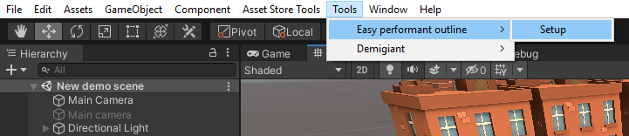

After follow the steps proposed by the wizard:

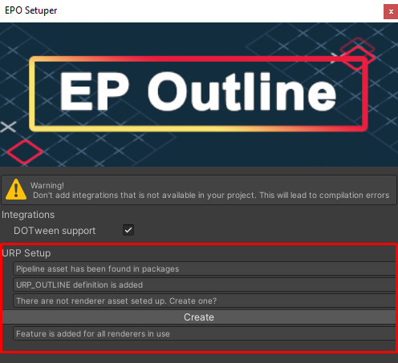

## **DOTween Setup**

You can enable **DOTween support** in the same menu under **Integrations** (*please enable it only if you have DOTween added to your project*):

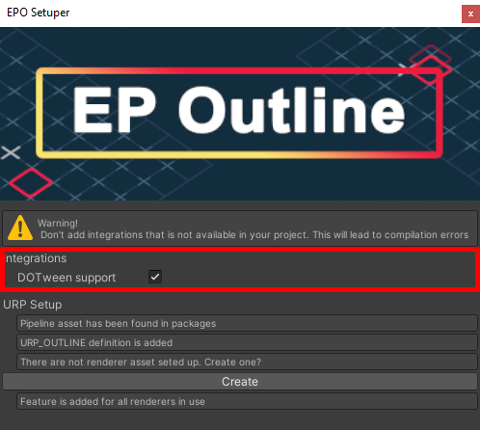

# **Easy Performant Outline 2.0**

**Easy performant outline** – is asset that provides high quality outlining for Unity. It supports various outline modes and features.

## **Components**

1. The *Outlinable* component is the component which indicates the objects which should be outlined by the outline system.

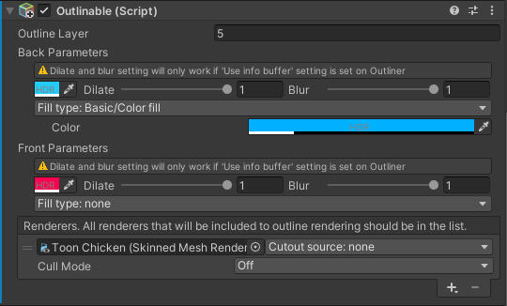

## **Parameters of Outlinable**

* **Outline layer**

The layer of the outline. In case if you should have a separate outline which can overlap you can select different layer for the outlinables and add several Outliners (More on that later). In this case the outlines will not interfear with each other.

* **Back parameters**

The parameters which will apply to the outline when it is obstructed by somethins (Let’s say behind the wall).

* **Front parameters**

The parameters which will apply to the outline which is directly visible (Not obstructed by anything).

**Parameters details (both front and back):**

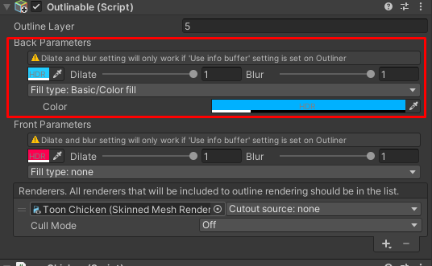

*Lets have a look at back parameters (The front works the same).*

First is the color of the outline. It will change the outline color. On the right hand side you’ll see dilate slider. If your outliner using info buffer (More on that later) you’ll be able to change per object dilate shift. To the right of that you’ll find a blur slider which is in case of using info buffer (More on that later) will change the amount of blur applied to each object.

Lower you’ll find Fill type selector. It’s a selector of the fill types available at the moment. Each of them might have different properties and describes how the fill should be rendered for each outlinable. If none is selected no fill will be applied.

* **Renderers**

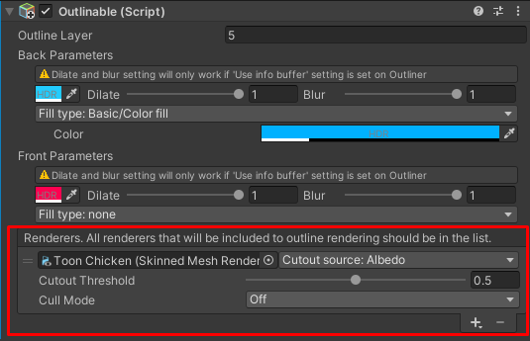

*The list which describes which targets should be rendered to produce outline.*

First parameter is the renderer which will be rendered in order to produce outline. Most of the time it should be all of the renderers included in your model/object. The disabled ones will not be rendered.

Cutout source is the paramter describing which of the texture the system should set as a cutout alpha source. In case if something is selecter there also will be Cutout threshould slider which is describing of how much alpha should the texture have in order to not be discarded.

Cull mode is the settings which is describing which cull mode should be used to render the outlinable target. Most of the time Back is the proper choise. In case of some geometry visible from both sides you should select Off. The Front setting should be used for extreme situations and is not commonly used but still exist.

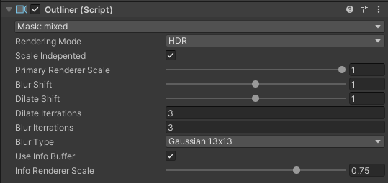

1. The ***Outliner*** component

* **Mask** – which layers should the outline render. If you selected some layers on the outlinables you can discard it from rendering by this exact outlier (Althrough you can add several of them to the same camera with a different layers).
* **Rendering mode** – Should outliner use HDR or LDR for the outline (In case of postprocessing like bloom it’s important to use HDR in other casese it’s a waiste of resources). Please note that HDR will not be used if the camera itself is not allowed to use HDR or the system is not supporting HDR.
* **Scale independent** – if set to true will try keep the same size inf you change Pimary renderer scale property. If set to false will increase the Blur/Dilate size if making primary renderer scale smaller (Might be intendent behaviour).
* **Primary renderer scale** – if the screen resolution is lets say 800:600 than in case of primary renderer scale is set to 0.5 will render outline in 400:300 resolution. It’s important to set the setting as low as possible while keeping intendent look of the outline.  
  The lower the value the better performance you gonna get.
* **Blur shift** – How much blur should affect the final image. In case of values larger than 1 might produce artifacts.
* **Dilate sift** – How much dilate should affect the final image. In case of values larger than 1 might produce artifacts.
* **Dilate iterations** – how many dilate effect iterations should be applied. The smaller the value the better performance you’ll get. The larger the value the stronger dilate effect you’ll get.
* **Blur iterations** – how many blur effect iterations should be applied. The smaller the value the better performance you’ll get. The larger the value the stronger blur effect you’ll get.
* **Blur type** – determines which of the blur types to apply. The most performant is BoxBlur, the most beautiful is Gaussian13x13.
* **Info buffer scale** – how should info buffer will be scaled down. 1.0 – the same side as the primary buffer. 0.1 – 1/10th of the primary buffer size. The smaller the value the better performance you’ll get.

# **Coding API**

In order to access the script in the script assigned to the same object as Outlinable:****

In order to add the outlinable in runtime you should use:



The Outlinable has multiple properties that can be changed throught scripting:Thank you for buying the **Easy Performant Outline**, we hope it will help you in your project.

If you liked our product, do not forget to rate it in an Asset store: <http://u3d.as/1EXT>

Your feedback will help me improve the project.

If you have any suggestions or questions, you can write to this email: [*pirate.parrot.software@gmail.com*](mailto:pirate.parrot.software@gmail.com)